**FPT International School**

--- o0o ---

**PROJECT REPORT**

**< Sound Blast** **>**

Batch: *T2205E1 FPT Aptech*

Semester: I

Group: 3

1. Bùi Tuấn Vũ (Leader)
2. Bùi Khương Duy
3. Bùi Duy Phước

Teacher : Phạm Thị Dung

**Hanoi - 10/2022**

**Table of Contents**

1. Problem Definition 3

i. Introduction 3

ii. Implementation Environment 3

2. UI\UX 7

2.1 GUI 1 (Example: Login Form) 7

2.2 GUI 2 (Example: Address Book Form) 7

2.3 GUI 3 8

2.4 … 8

3. Summary 10

# Problem Definition

### Introduction

As the world’s largest music and audio platform, **SoundBlast** lets people discover and enjoy the greatest selection of music from the most diverse creator community on earth. The platform has become renowned for its unique content and features, including the ability to unearth breakthrough tracks, raw demos, podcasts and more. This is made possible by an open platform that directly connects creators and their fans across the globe. Music and audio creators use SoundBlast to share their content with a global audience, as well as receive detailed stats and feedback from the SoundBlast community.

### Implementation Environment

1. HTML :

* The Top of the Page should be presented with a suitable logo
* The site must contain following sections with proper listing of songs and albums.
  + Trending Now
  + Top Charts
  + New Releases
  + LATEST ALBUMS
  + GENRES
  + OLD SONGS
  + TOP ARTISTS
  + LANGUAGES
  + TOP SEARCHED SONGS
* Gallery can be added for viewing different images.
* It should also display the reviews about various albums or artists under reviews section
* Feedback must be allowed to enter by the viewer
* About Us, Site map, Gallery, about us, Queries link, Contact us link must be added.
* There would be two types of users: registered and non-registered users.
  + Registered users should be able to download the complete album whereas non-registered users should only be able to listen the album but no downloading allowed for them.
* Over and above this, the portal should implement the following functionalities:
* Display a continuous scrolling ticker at the bottom of the page with current date, time, and location (hint: Use geolocation features of HTML5).
* Display a visitor count at the top right corner of the page beside a logo image.
* The menu options should change color on hover and also after clicking.
* Fade in and fade out options can be used for the menus.

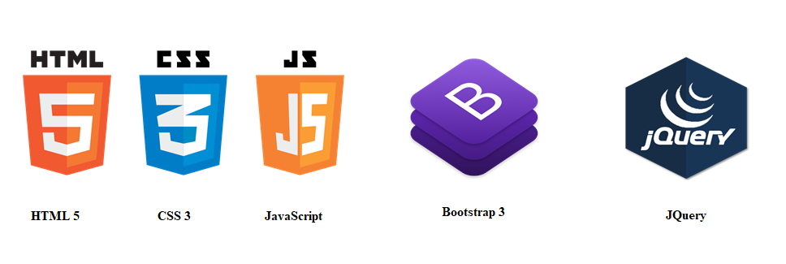   

* HTML :
* HTML stands for Hyper Text Markup Language
* HTML is the standard markup language for creating Web pages
* HTML describes the structure of a Web page
* HTML consists of a series of elements
* HTML elements tell the browser how to display the content
* HTML elements label pieces of content such as "this is a heading", "this is a paragraph", "this is a link", etc.
* CSS:
* CSS stands for Cascading Style Sheets
* CSS describeshow HTML elements are to be displayed on screen, paper, or in other media
* CSS saves a lot of work. It can control the layout of multiple web pages all at once
* External stylesheets are stored in CSS files
* Bootstrap 5:
* Bootstrap is a free front-end framework for faster and easier web development
* Bootstrap includes HTML and CSS based design templates for typography, forms, buttons, tables, navigation, modals, image carousels and many other, as well as optional JavaScript plugins
* Bootstrap also gives you the ability to easily create responsive designs
* Javascript :

JavaScript is a programming language commonly used in web development. It was originally developed by Netscape as a means to add dynamic and interactive elements to websites. While JavaScript is influenced by Java, the syntax is more similar to C and is based on ECMAScript, a scripting language developed by Sun Microsystems.

JavaScript is a client-side scripting language, which means the source code is processed by the client's web browser rather than on the web server. This means JavaScript functions can run after a webpage has loaded without communicating with the server. For example, a JavaScript function may check a web form before it is submitted to make sure all the required fields have been filled out. The JavaScript code can produce an error message before any information is actually transmitted to the server.

* JQuery:  
   jQuery is a JavaScriptlibrary that allows web developers to add extra functionality to their websites. It is open source and provided for free under the MIT license. In recent years, jQuery has become the most popular JavaScript library used in Web development.

To implement jQuery, a web developer simply needs to reference the jQuery JavaScript file within the HTML of a webpage. Some websites host their own local copy of jQuery, while others simply reference the library hosted by Google or the jQuery server.

* Photoshop CS6:

Adobe Photoshop CS6 is a raster graphic editor developed and published by Adobe Inc. for Windows and macOS . It was originally created in 1988 by Thomas and John Knoll. Since then, the software has become the industry standard not only in raster graphics editing, but in digital art as a whole.

* JSON :

SON stands for **J**ava**S**cript **O**bject **N**otation

JSON is a **text format** for storing and transporting data

JSON is "self-describing" and easy to understand

JSON can very easily be translated into JavaScript.

JavaScript can be used to make HTML in your web pages.

## How do I read a JSON file in Notepad ++?

Open notepad++ -> ALT+P -> Plugin Manager -> Selcet JSON Viewer -> Click Install.

Download JSON viewer plugin for notepad++ from sourceforge.

Copy NPPJSONViewer.dll into Notepad++\plugins\NPPJSONViewer folder.

restart the notepad++select JSON and click on plugins > JSON Viewer > Format JSON (CTRL+ALT+SHIFT+M).

Done.

* Visual Studio Code

Visual Studio Code is one of the most popular code editors out there. It's free, it has a clean interface, and it has countless extensions which make programming easier and more fun.

* Using the Live Server in Visual Code

Step 1: Install VS Code.

You can skip this part if you have already installed VS Code on your computer. Otherwise, you can download it from [its official website](https://code.visualstudio.com/).

After you've downloaded and installed VS Code, you are going to see the welcome screen:

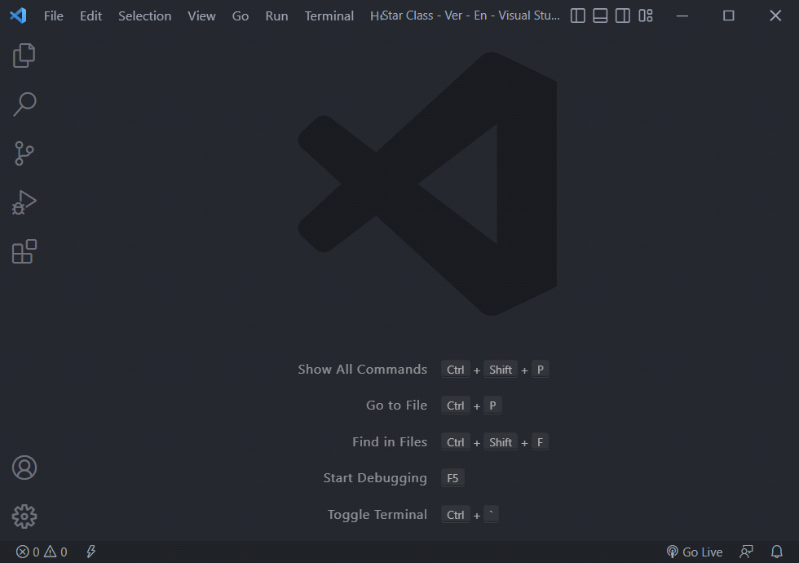

On the left side, you see a couple of icons. One of them (under the no bugs icon) is the extensions button:

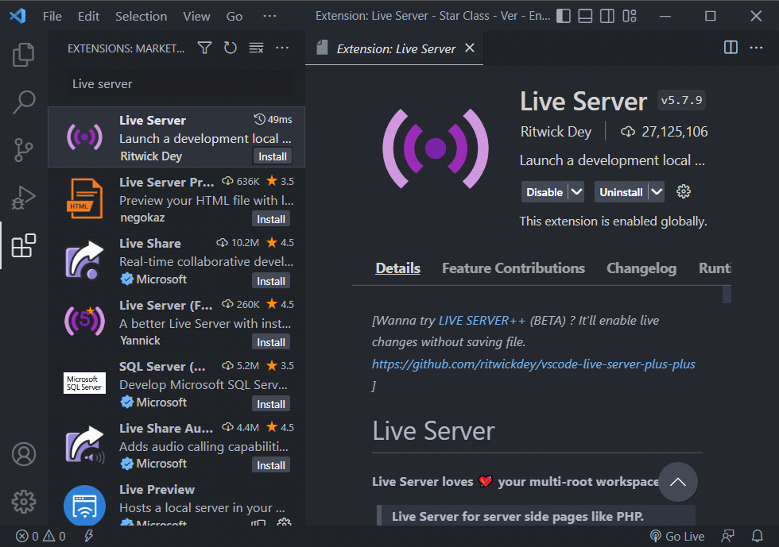

Once you click on it a search bar will appear. Just type in “live server”.

You will see many options, so you can choose whichever one works for your system. I use Live S

erver by Ritwick Dey, so let's continue with that one in this example:

Click on the install button and it will install the extension.

Step 2: Launch our website on a live server.

Launch Visual Studio Code.

Select our project's root directory.

On the Visual Studio menu bar, choose File > Open > Folder, and then browse to the our code location.

Choose to open your homepage's index.html file:

Method 1: Right click and select Open with Live Server.

Method 2: In Visual Studio Code, click the Go Live icon in the Status bar.

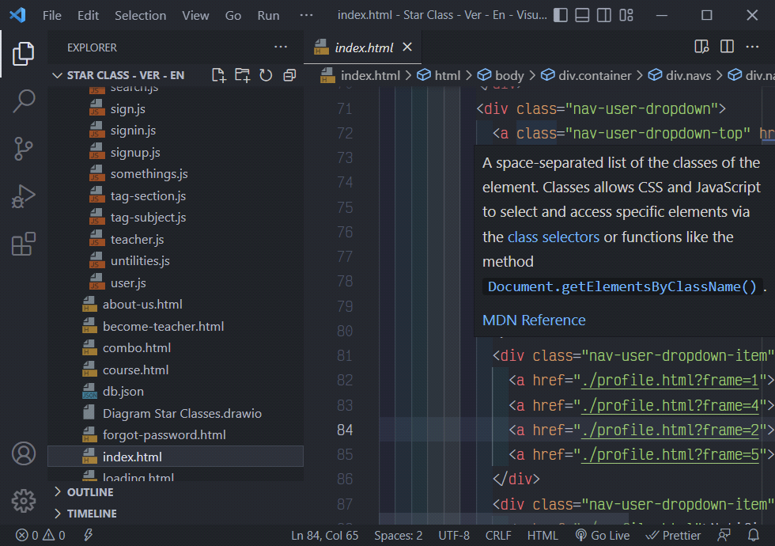

Now start localhost and a browser tab will open with Starclasses. Enjoy it.

1. **UI\UX**

## GUI 1 (Example: Home page)

3.1.1: Find out about the homepage.

* The homepage of Sound Bast is designed carefully with an eye-catching, friendly and customer-friendly interface. The layout of the buttons on the Navigation Bar is designed with easy-to-see distance, creating comfortable feeling for users. The menu options should change color on hover and also after clicking
* Songs, mvs, albums are added with eye-catching visuals.

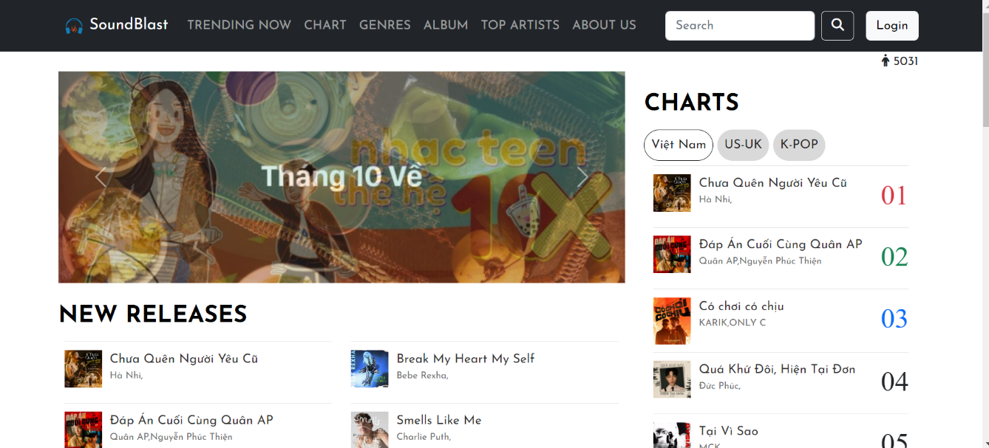

* At the top of the page, there will be a photo slidebar to introduce recent hot topics as well as newly released songs
* On the Chart section of the homepage, we create buttons called VN, US-UK and K-Pop to view rankings by languages.
* The number of visitors is also displayed in the top right corner of the page.

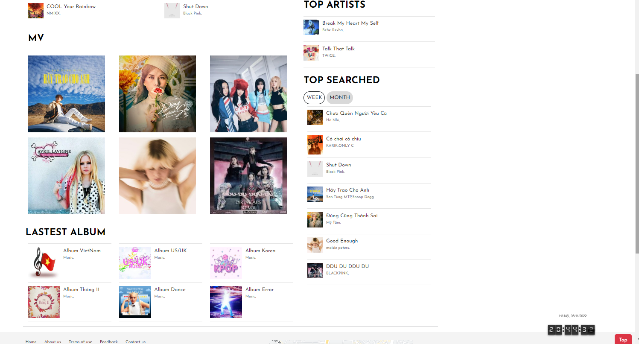

* At the bottom of the homepage there are sections like MV, Top Artists, Top searched, lastest album, as well as scrolling codes that show up continuously at the bottom of the page with the current date, time, and location.
* Besides, the arrow to move to the top will appear in the lower right corner of the screen

3.1.2: (Example: **Detail Sound**)

* When you click on any song, a music video will open a link to the music detail page.

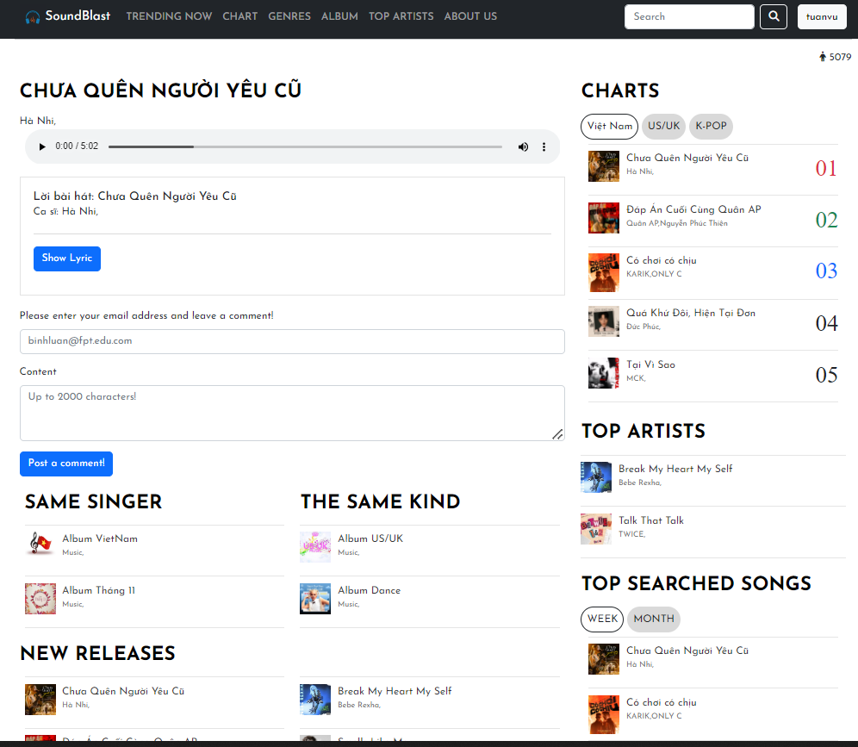

In addition to the main music player function, when you click on the 3 dots you can download the song or video or adjust the playback speed of that video song.

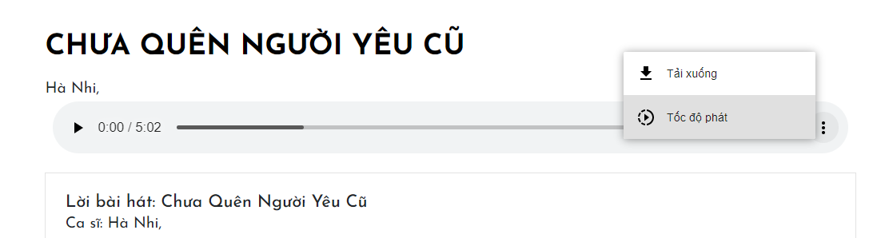

3.1.3 (Example: **Opinion form)**

* When you click the Showlyric button, the lyrics will be displayed, as well as you can click the HideLyric button to hide it.

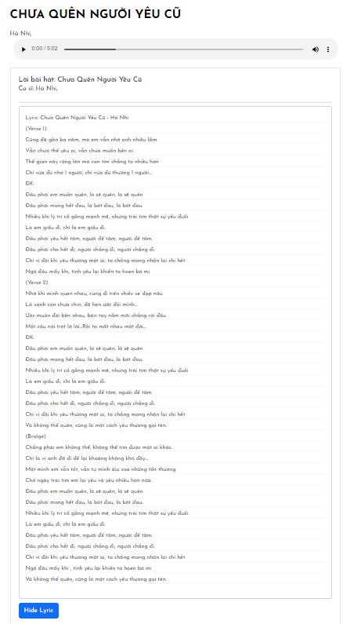

* Below the lyric section, there will be a section for users to leave comments on the song they want to rate

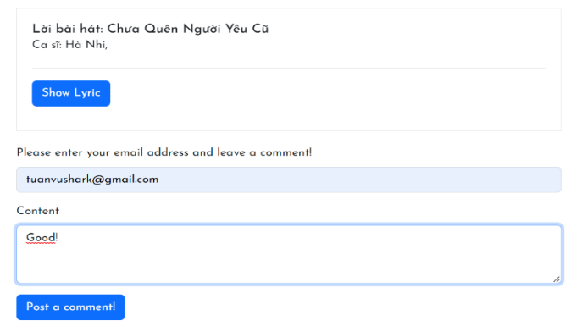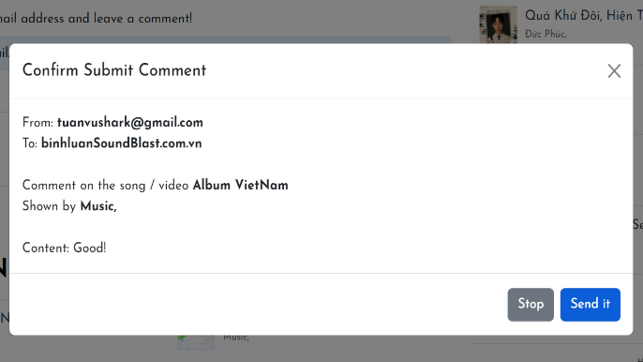

## GUI 2 (Example: Following requirements)

3.2.1 When you click on Trending now menu a link will be opened with top trending songs and Mvs.

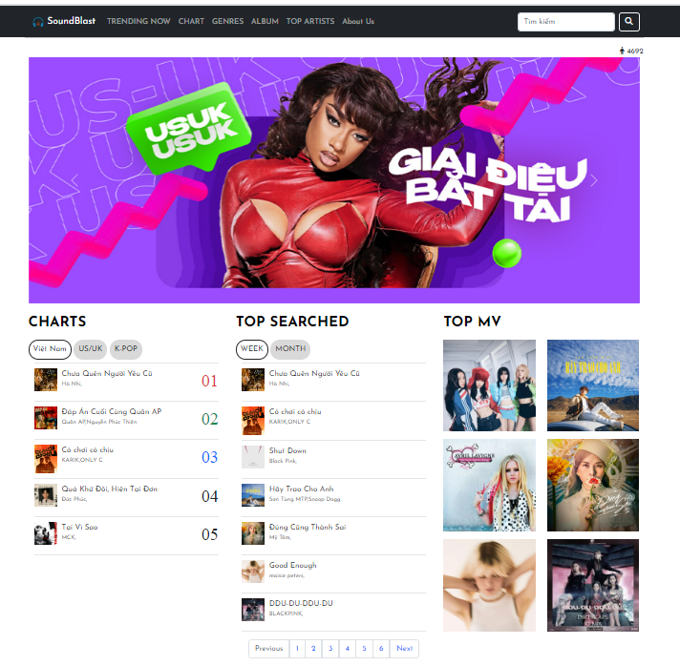

1. Next is the Charts page.

Here you can follow the up and down chart of the top 3 ranked songs by lines with symbolic colors according to each song's chart and by time period in 24 hours.

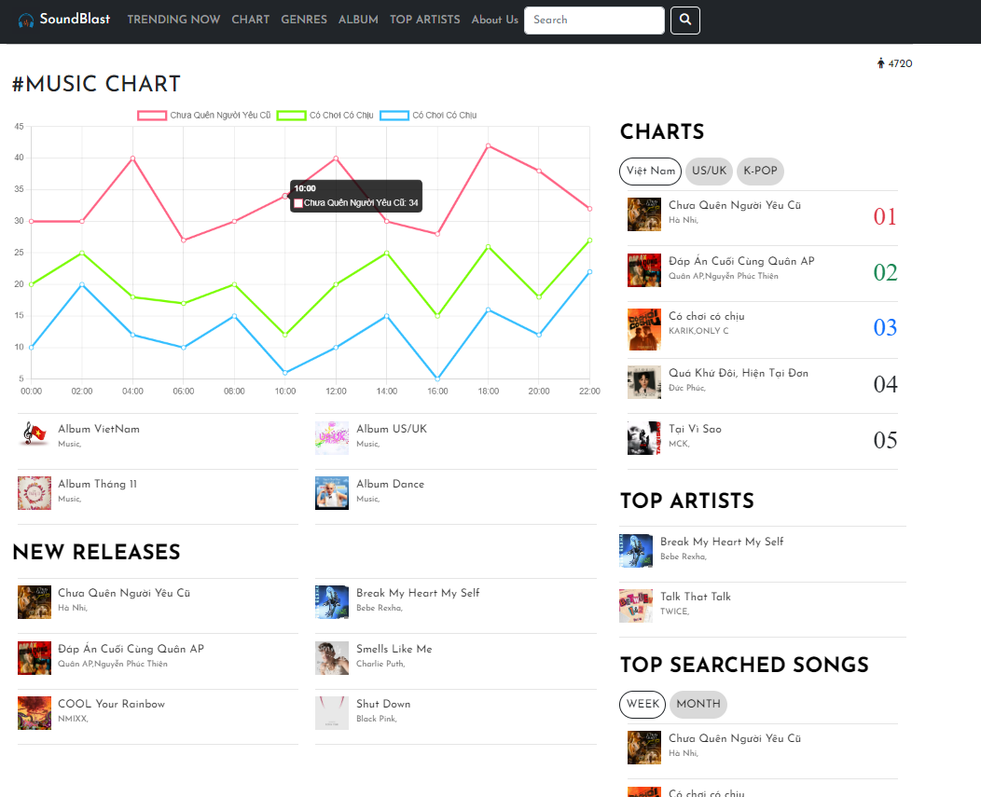

1. Music genre page with today's popular music selections, making it easy to search for music by theme you want.

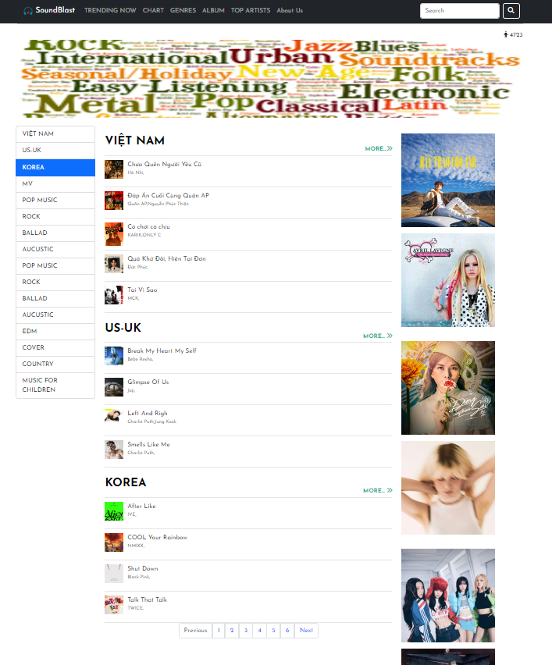

1. Latest albums collects the latest albums of singers around the world to help you have an enjoyable listening experience.

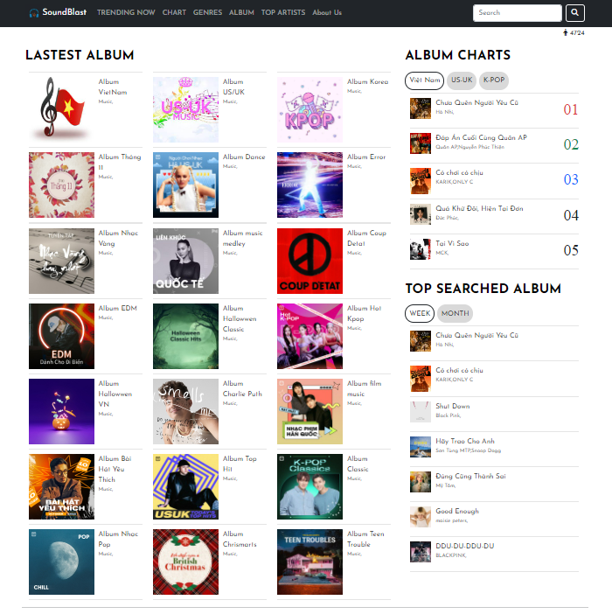

1. Finally, there is a page about the top singers with specific images of each singer, making it easy for you to find your favorite singer.

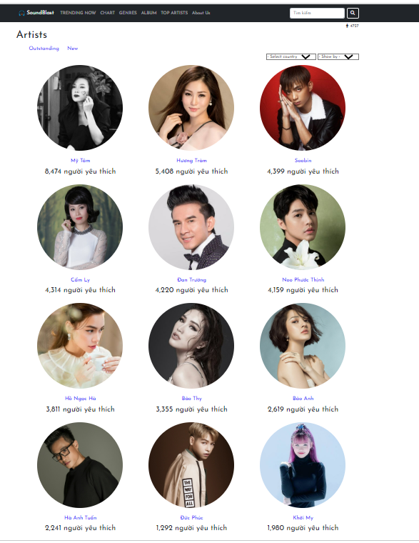

## GUI 3 (Example: Contac Us)

3.3.1

* You can contact each member of our team with information about mobile, mail, and address

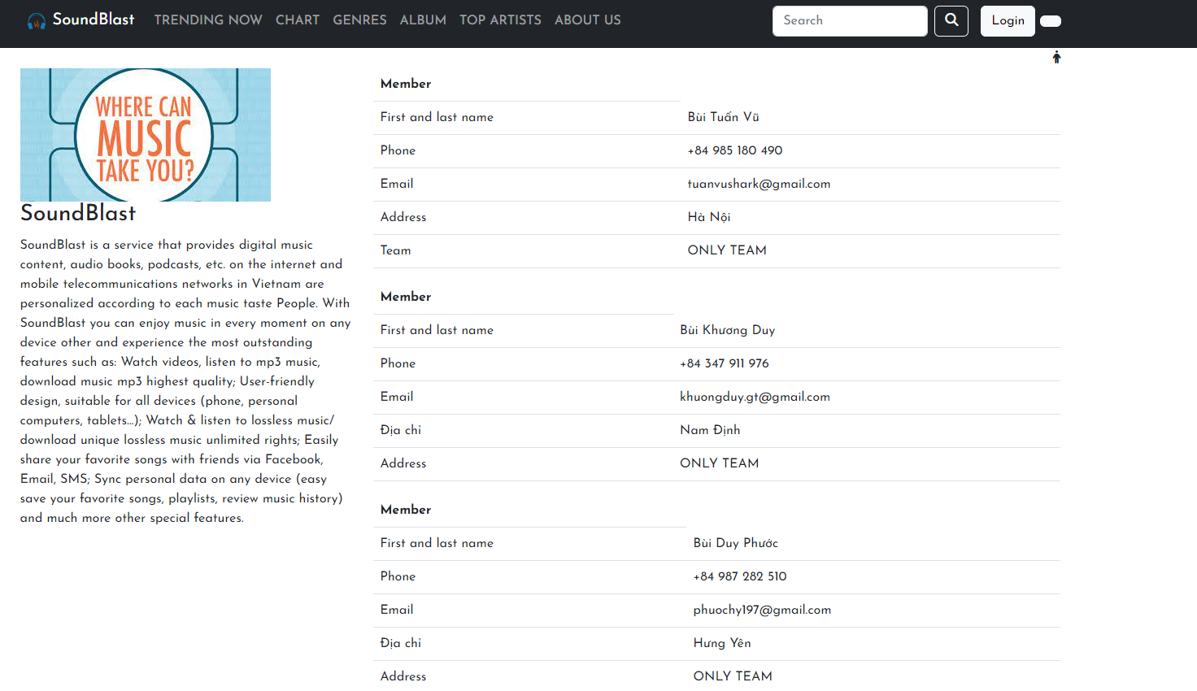

3.3.2 Also below you can directly leave a message via email with us:

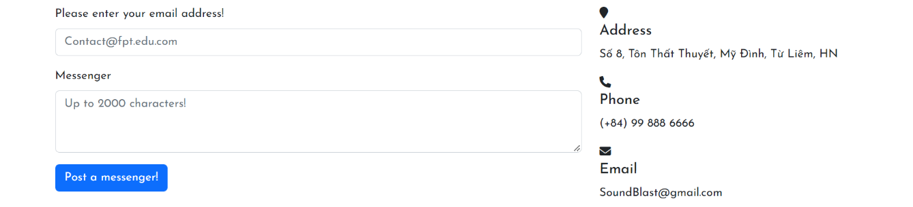

## 2.4 GUI 4 (Example: Login)

3.4.1

When you click on the login menu in the top right corner, a form will appear to help you log in to the website to be able to download all your favorite songs.

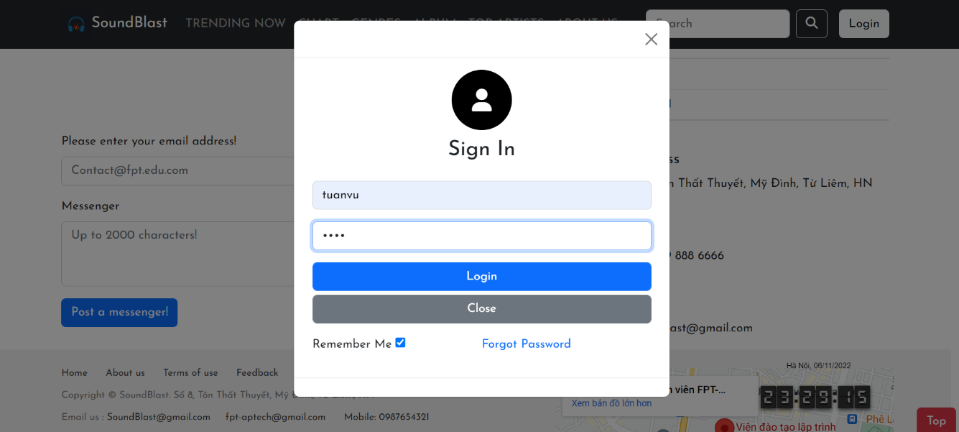

## 2.5 GUI 5 (Example: Footer)

3.5.1

* The footer is designed with links, contact, address, feedback included. In addition, the specific address is also displayed on the map.

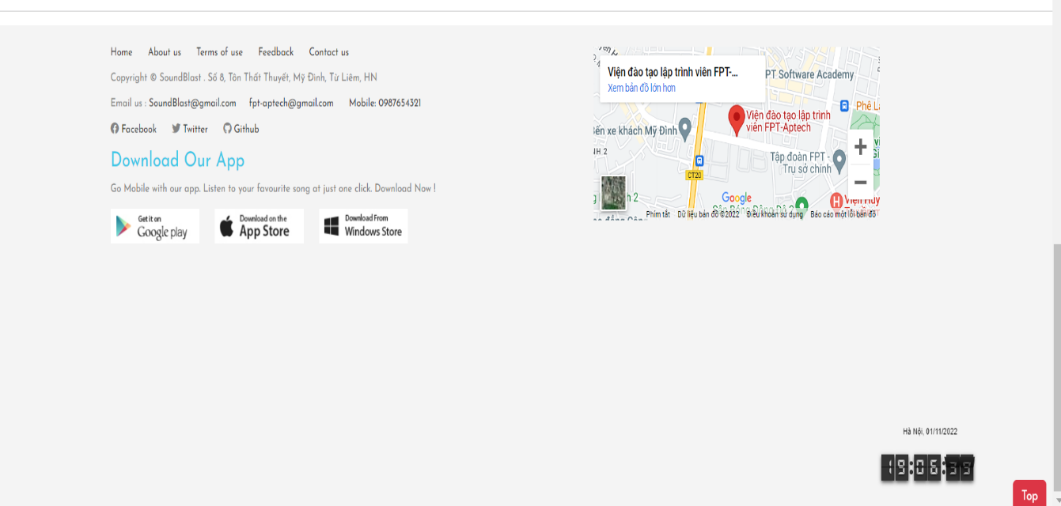

**4. Summary**

SoundBlast is a service that provides digital music content, audio books, podcasts, etc. on the internet and mobile telecommunications networks in Vietnam are personalized according to each music taste People. With SoundBlast you can enjoy music in every moment on any device other and experience the most outstanding features such as: Watch videos, listen to mp3 music, download music mp3 highest quality; User-friendly design, suitable for all devices (phone, personal computers, tablets...); Watch & listen to lossless music/ download unique lossless music unlimited rights; Easily share your favorite songs with friends via Facebook, Email, SMS; Sync personal data on any device (easy save your favorite songs, playlists, review music history) and much more other special features.